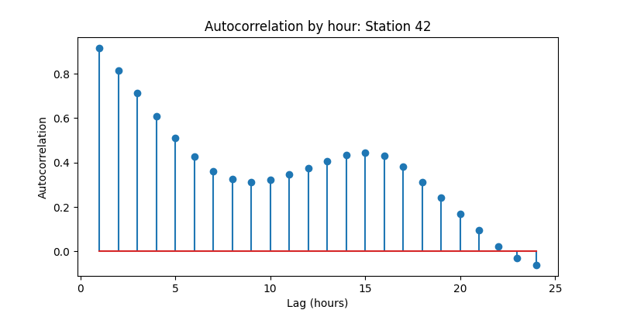
The bike availability at Station 42 exhibits strong short-term autocorrelation (ρ ≈ 0.90 at 1 hour), indicating high persistence in usage over a few hours. Autocorrelation declines through the next 6–10 hours, consistent with daily commuting cycles causing greater variation in station occupancy. A secondary peak around 12–16 hours suggests a daily periodic pattern in bike usage, before eventually declining toward zero. This structure indicates that bike availability is highly predictable at short horizons and moderately predictable on a daily cycle.

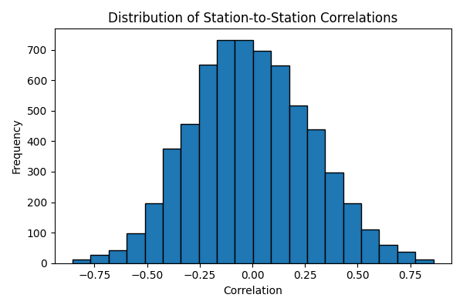
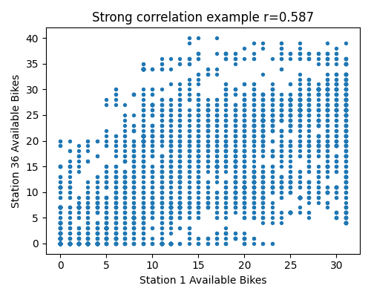
To assess cross-station independence, we computed the Pearson correlation between the bike availability time series of all station pairs. A correlation heatmap and histogram indicate that while many station pairs exhibit weak correlation, several clusters of stations show moderate to strong correlation. This suggests that bike availability is influenced by shared demand patterns, such as commuting flows, weather or coordinated redistribution, and the assumption of full independence between stations may not strictly hold.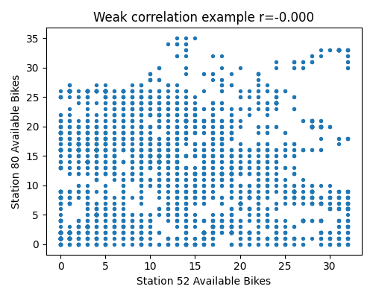

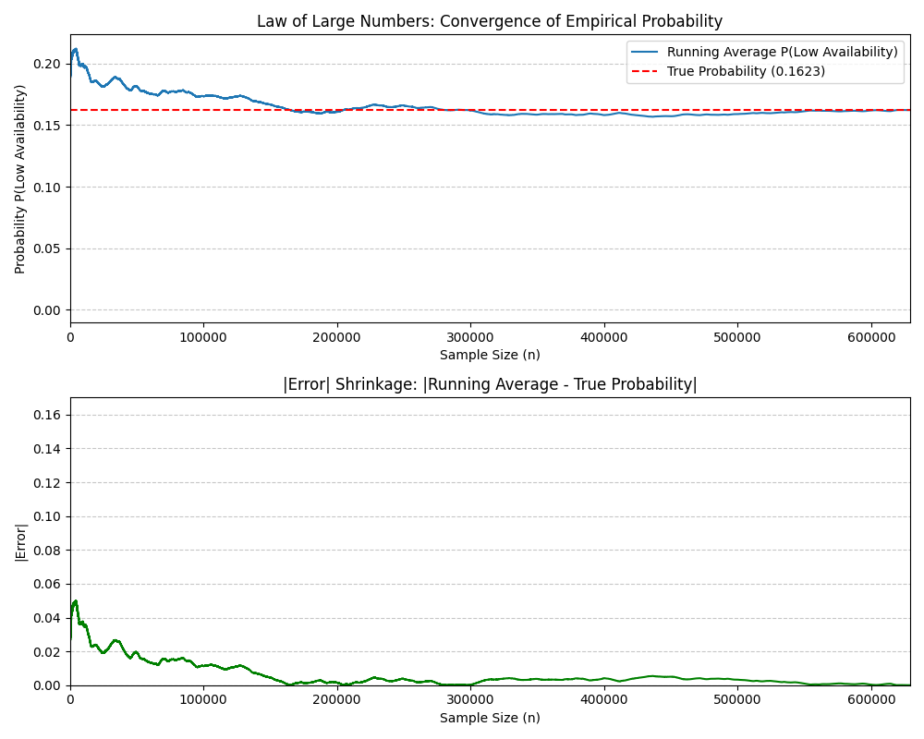
Based on the Law of Large Numbers analysis of Dublin Bikes station data, the empirical probability of low availability (fewer than 2 bikes available) converges to approximately 0.1623 or 16.23%. The convergence visualization demonstrates the fundamental principle of the Law of Large Numbers: as sample size increases from initial observations to over 600,000 data points, the running average of low availability events stabilizes around the true probability. The error shrinkage plot reveals rapid initial fluctuations with absolute errors exceeding 0.05 in early samples, which systematically decrease and approach zero as more observations accumulate. This convergence behavior confirms that with sufficient data, the empirical frequency of low availability events becomes a reliable estimator of the underlying probability, validating the use of historical data for predicting station availability patterns in the Dublin Bikes system.

